Lecture 1, 2

Function, Limit and Continuity

Lecture 3

Derivative:

C:\Users\masud\Desktop\Capture2.JPG

Point.

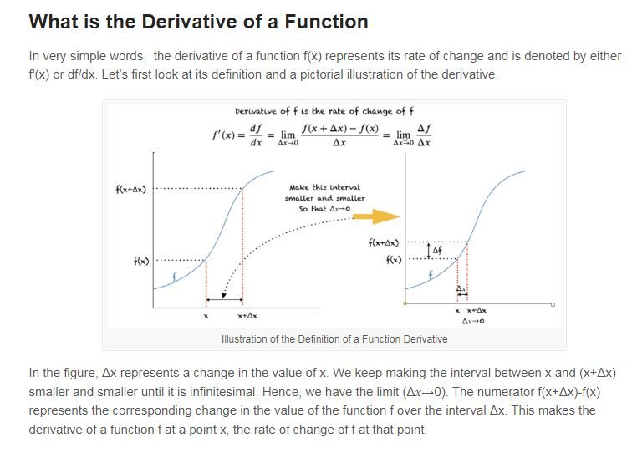

Find the derivative of the following

1. 



1. Example 



1. 



1. 



1. 



1. 



1. 



1. 



1. 



1. 



Lecture 4, 5

Find the differential coefficient of the following

1. 
2. 

Solution: (i)





 …………………………………………………………..(1)

 and 

 and 







Again 



From (1), We get





Find the differential coefficient of the following

1. 

ii) 

Solution: , 

Find the differential coefficient of the following

i)  with respect to 

Solution:  with respect to 

We have to find 

 , 



Lecture 6

If, the succssive derivative are also denoted by









 standing for the symbol 

1. The nth derivative of some special functions











and proceeding in a similar mannner







1. 









and proceeding in a similar manner





**Leibnitz’s theorem:** (nth derivative of the product of two functions)

If  and  are two functions of , then the nth derivative of their product i.e.,



where the suffixes in and denote the order of differentiations of  and  with respect to 

Let  By actual differentiation, we have 





The theorem is thus seen to be true when n=2 and n=3.

Let us assume therefore that



Where n has any particular value.

Differentiating,



Since  and 



Thus, if thetheorem holdsfor n differentiations, it also holds for n+1. But it was proved to hold for 2 and 3 differentiations. Hence it holds for four, and so on, and thus the theorem is true for every positive integral value of n.

Lecture 8

Example: If  then (i) 

(ii) 

Solution:



By leibnitz’s theorem









Example: If  then

(i) 

Example: If  then

(i) 